**PROJECT REPORT TEMPLATE**

1 INTRODUCTION

1.1 Overview

The creating salesforce developer org is the first step of project activity and create username and password is mainly to enter salesforce.com. We want to create 3 objects School, College and Parent. All the milestones are based on the 3 objects. Totally 8 milestones are given Create Salesforce Developer Account, Object, Lightning App, Fields Relationship, Profile, Users, Permission Sets, Reports. Each milestones or activities is related to other milestones. Second milestone is to creating three objects. Third milestone is to creating the School Management App. Fourth milestone is to creating fields for the School, Student and Parent objects. Fifth milestone is to creating on Profile. Sixth milestone is to creating a Users. Seventh milestone is to create a permission set 1 and 2. Eighth and final milestone is to creating a Report for Schools and Colleges.

1.2 Purpose

A CRM Application For Schools And Colleges is a software application used to automate and handle communication with current students, Employees, Alumni. All this work is done on a single system. Every connection with customer is tracked by the customer relationship management system in one place. With the help of customer relationship management software , you can take the feedback from the customers, department and students. Each interaction with your customers is tracked by the customer relationship management system. As, at a time there is an increase in the volume of leads, at that time this software is beneficial. This leads to enhancing the work efficiency and visibility of a business.

2 PROBLEM DEFINITION & DESIGN THINKING

2.1 Empathy Map

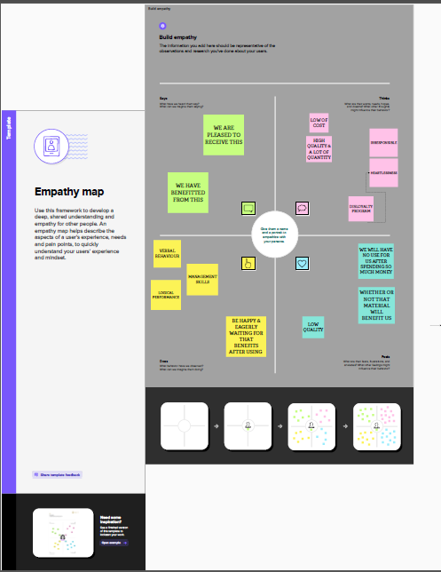

2.2 IDEATION & BRAINSTORMING MAP

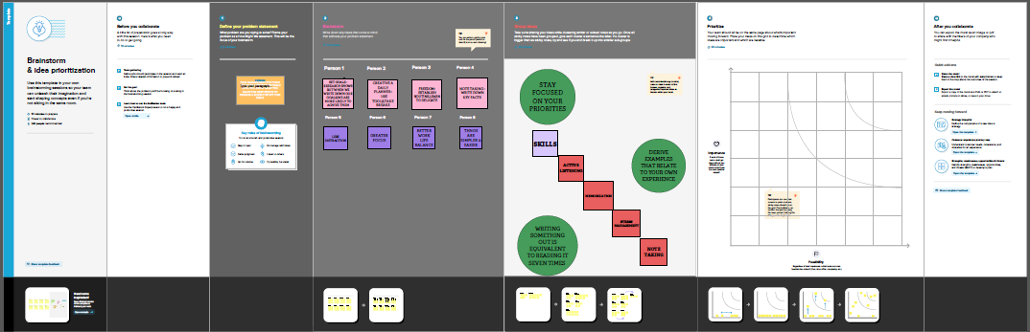

3 RESULT

3.1 Data Model

|  |  |  |
| --- | --- | --- |
| Object Name | Fields in the object |  |
|  | Field Label | Data Type |
|  | Address | Area |
| Schools | Phone Number | Phone |
|  | Number of students | Roll up – summary field |
|  | Highest marks | Roll up – summary field |

|  |  |  |
| --- | --- | --- |
|  |  |  |
|  | Field Label | Data Type |
|  | Phone Number | Phone |
| students | School | Master Detail Relationship |
|  | Class | Number |

|  |  |  |
| --- | --- | --- |
|  |  |  |
|  | Field Label | Data Type |
| Parents | Parent Address | Text Area |
|  | Parent Number | Phone |

3.2 Activity & Screenshot

ACTIVITY – 1

Creating Development Account

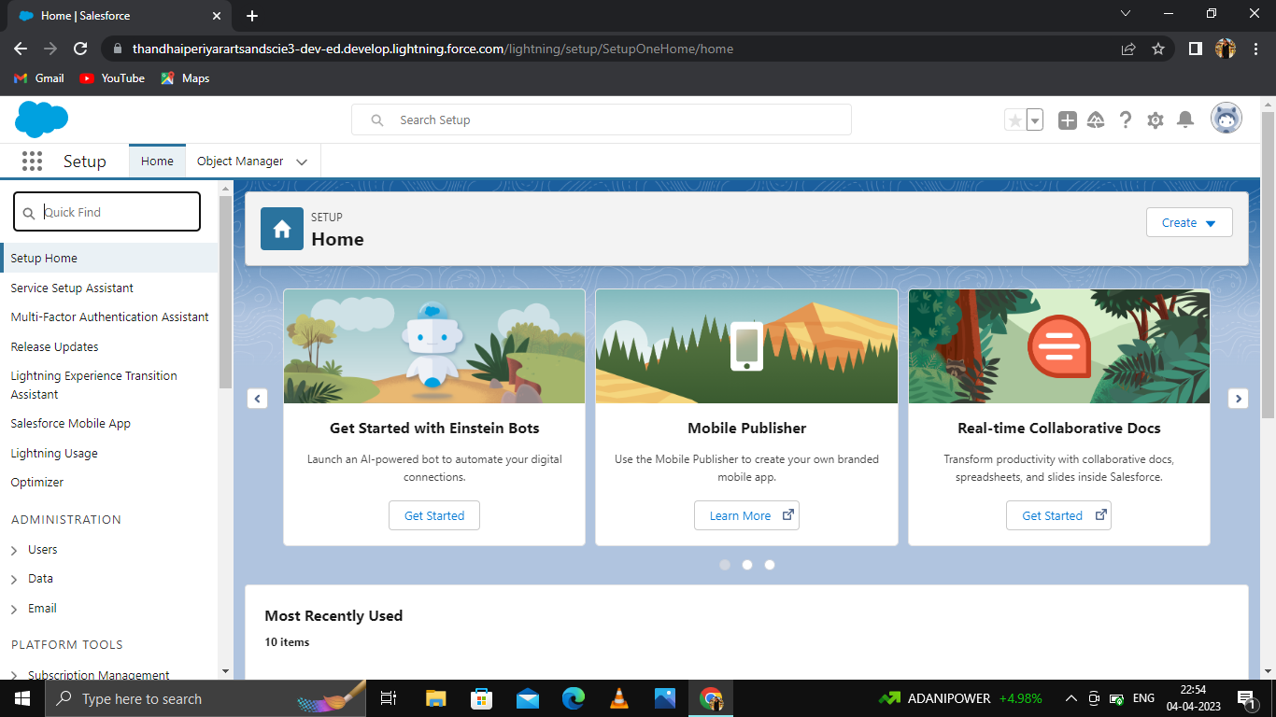

Description

* To create an account on salesforce .org.
* After login to salesforce account enter username and password.
* After login this homepage you will start the project.

ACTIVITY – 2

Creating objects – Schools , Students , Parents

1. Schools

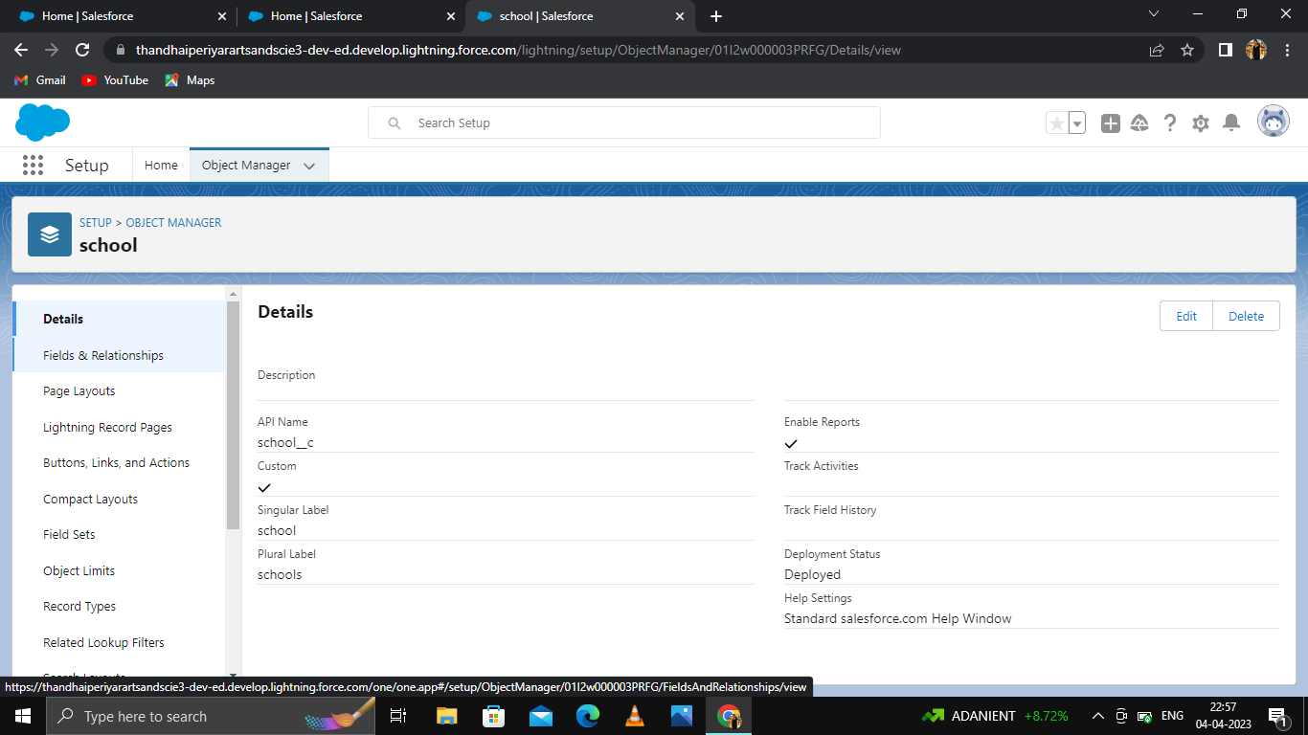

1. Students

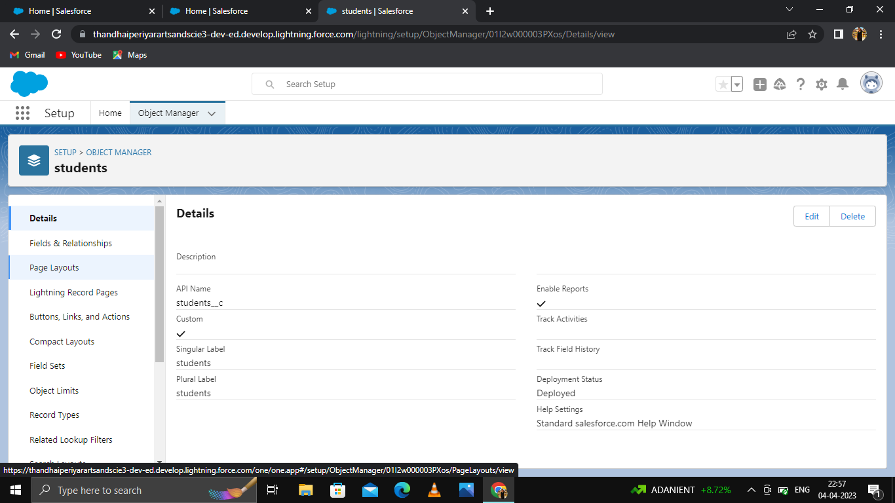

1. Parents

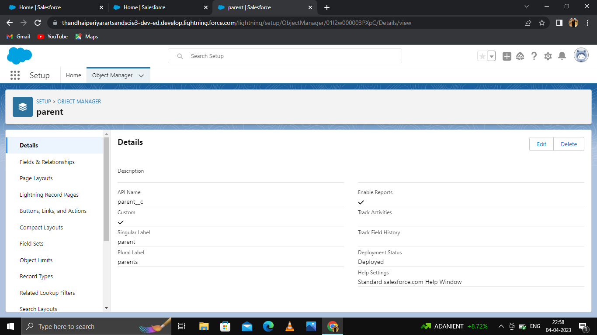

Description

* Create all objects :
* Schools
* Students
* Parent
* After check your object in quick find box.
* On custom object page
* Enter the label name, plural label name, click on allow reports, allow search and save.

ACTIVITY – 3

Creating fields and relationship for above custom objects

1. Schools

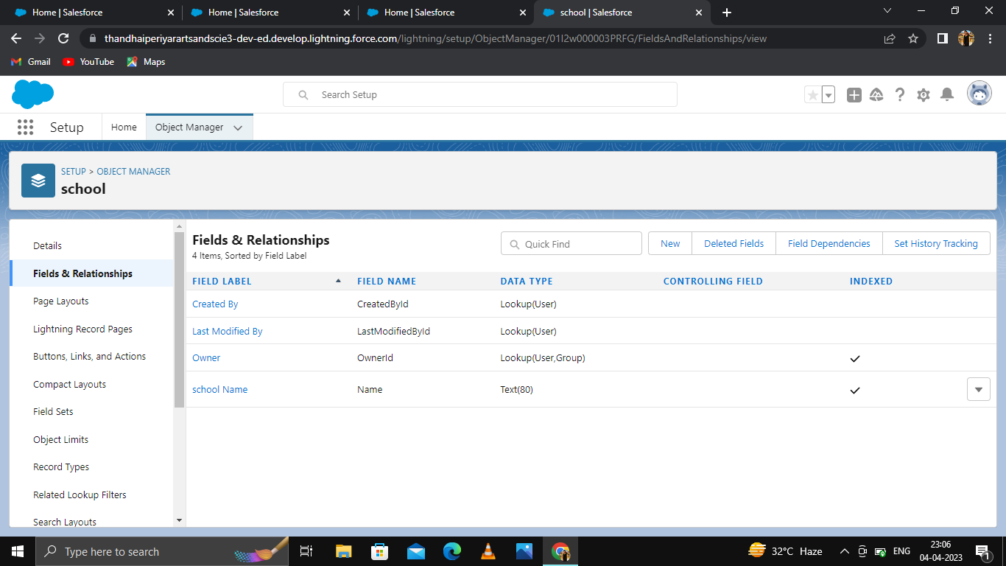

1. Students

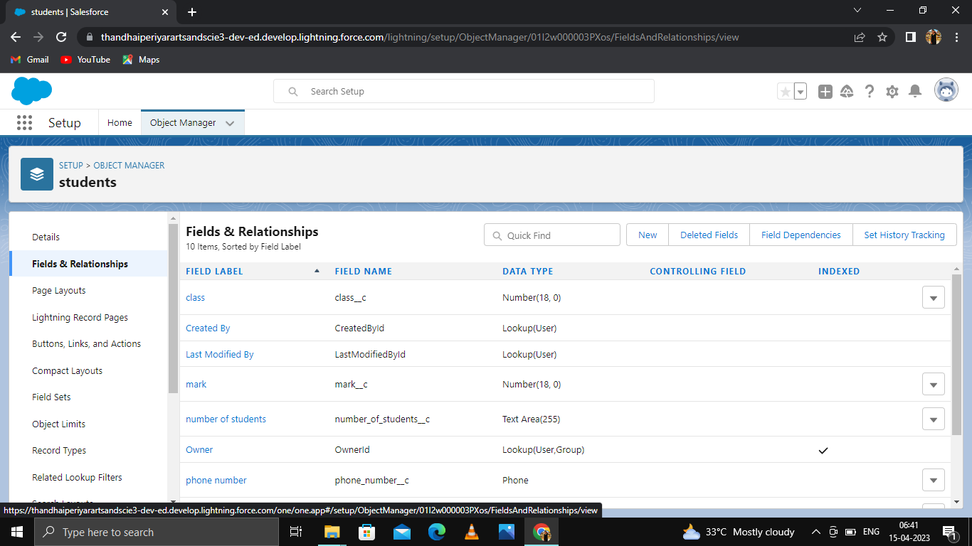

1. Parents

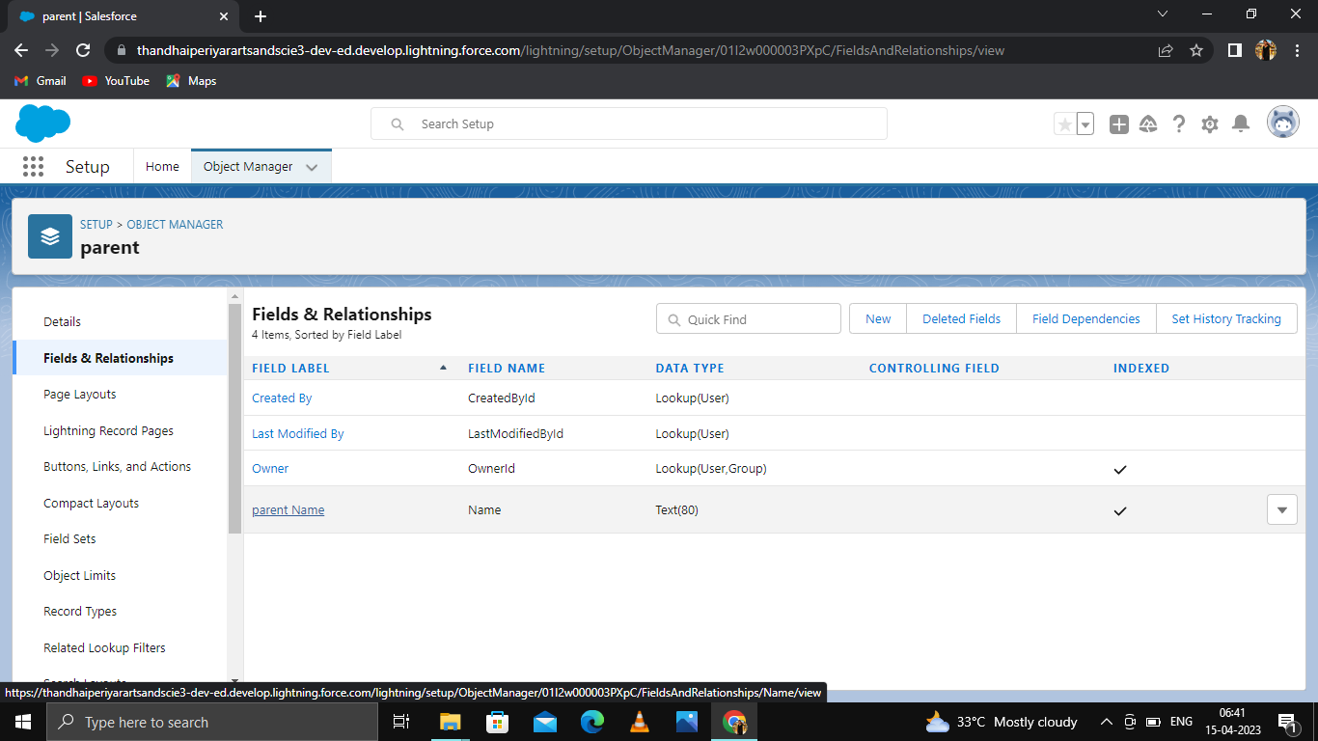

Description

* Click object manager. Select school, students & parents.
* Click fields and relationships.
* Select data type and enter field label.
* Click next and save.

ACTIVITY – 4

To creating a different users.

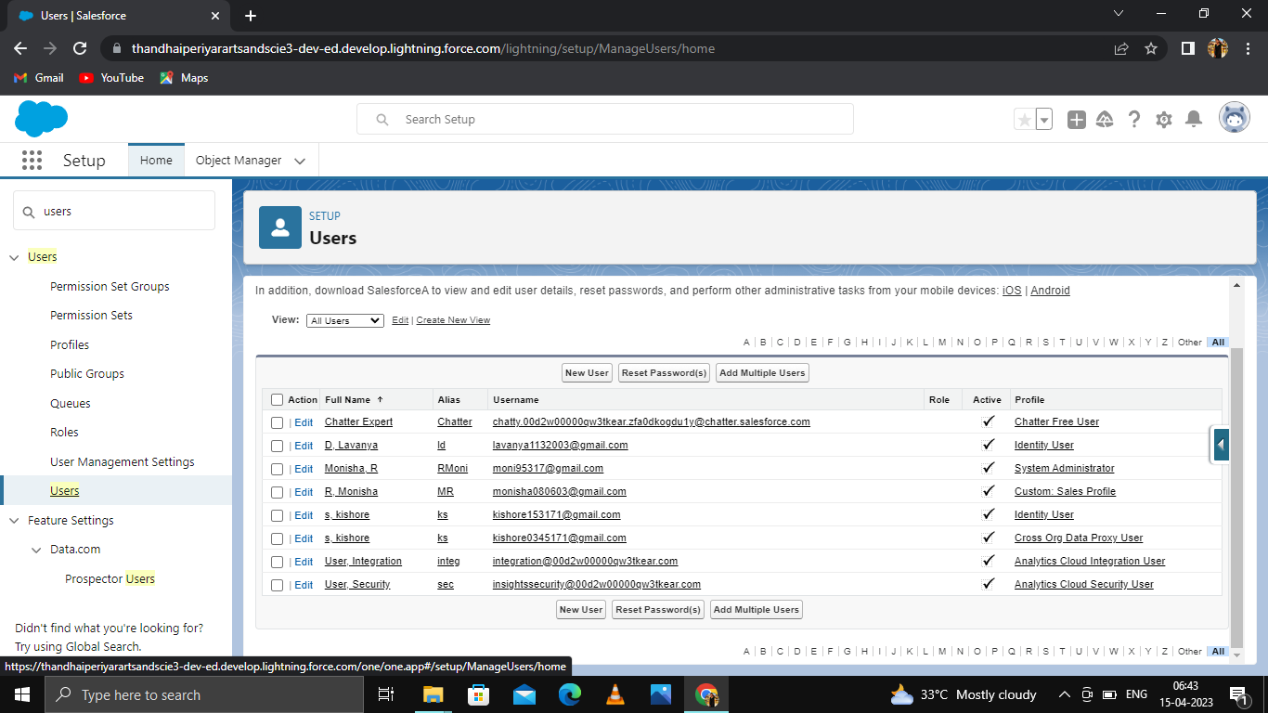

Description

* A user is anyone logs in to salesforce.
* Who need access to the company’s record. Every user in salesforce has a user account.
* Create salesforce user in lightning app

ACTIVITY – 5

To creating a Report.

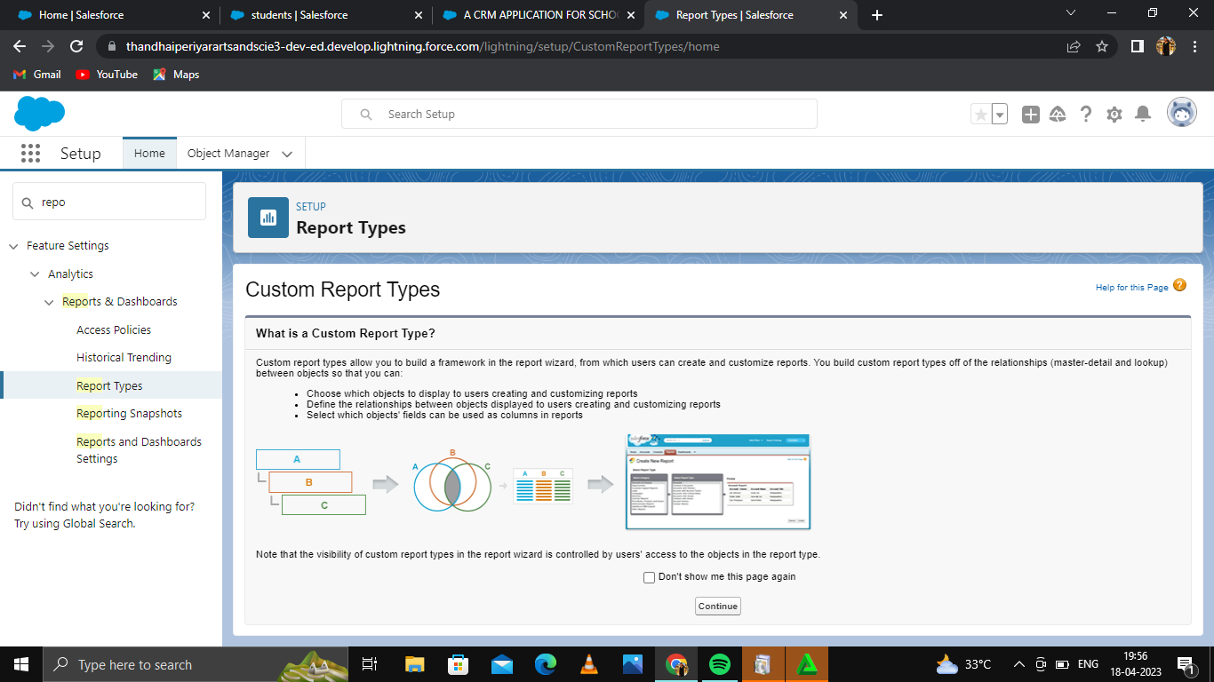

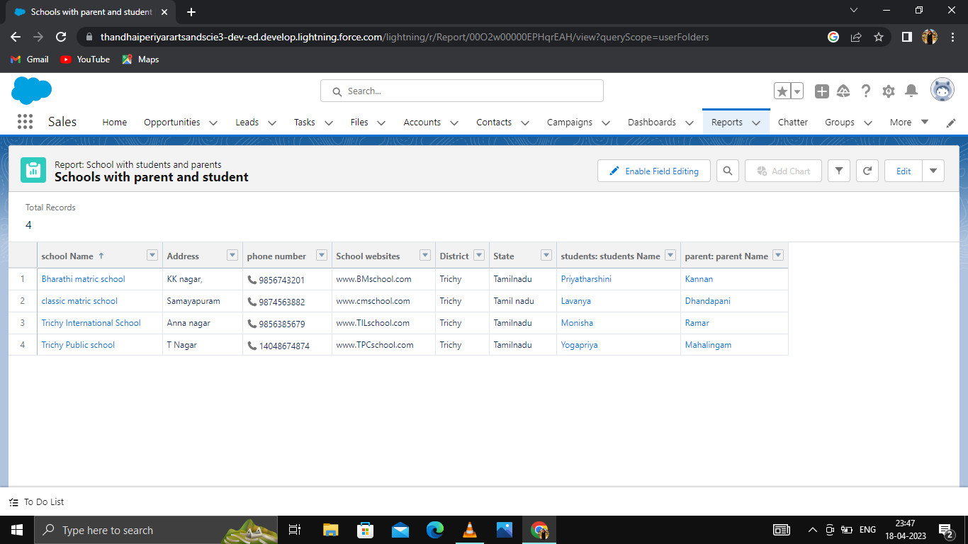

1. TRAILHEAD PROFILE APUBLIC URL

Team Head: Monisha.R - https://trailblazer.me/id/rmonisha1

Team Members:

1. Ponni. J - https://trailblazer.me/id/ponnj3

2. Priyadharshini. K - https://trailblazer.me/id/priyk59

3. Sandhiya. S - https://trailblazer.me/id/ssandhiya11

4. Yogapriya. M - https://trailblazer.me/id/ypriya43

5 ADVANTAGES & DISADVANTAGES

5.1 Advantages

* Improved organization: A CRM application can help schools and colleges to keep track of student-related data, such as contact information, academic progress, attendance, and communication history, more efficiently.
* Enhanced communication: The CRM application can help in developing better parent-teacher relationships by providing a platform where they can communicate with each other conveniently.
* Increased efficiency: A CRM application can automate certain administrative tasks such as grading and attendance reports, saving educators a considerable amount of time.
* Integrates with other systems: The CRM application can integrate with other school management systems such as academic platforms and admission portals, streamlining the entire administrative process.

5.2 Disadvantages

* Cost: The implementation and maintenance of a CRM application can be expensive, making it difficult for smaller educational institutions to afford it.
* Data privacy: Maintaining the privacy and confidentiality of student information is critical. A data breach or unauthorized access to information can result in major consequences.
* Need for training: Teachers and staff members may need training to use the CRM application effectively, which requires time and resources.
* Overreliance on technology: While a CRM application can improve organizational efficiency, there is a risk of over-reliance on technology that could lead to a lack of personal and human touch.

6. APPLICATIONS

* The application should allow schools and colleges to manage student registration, including personal details, academic records, attendance, and other relevant information.
* The application should include features for managing communication between students, staff, and faculty members.
* The application should also have a feature for collecting feedback from different users, including students, staff, faculty, and other stakeholders.

7. CONCLUTION

* A CRM application for schools and colleges brings a wide range of benefits to educational institutions.
* This software provides a centralized platform for managing all aspects of the educational process, from enrollment to graduation. It can help administrators to better understand the needs and preferences of their students, streamline communication and collaboration between different departments, and ultimately enhance the overall student experience.
* With the help of a CRM application, academic institutions can improve operational efficiency, increase student satisfaction, and ultimately achieve better outcomes.
* As such, investing in a CRM application can help schools and colleges stay competitive and meet the evolving needs of their students and stakeholders.

8. FUTURE SCOPE

* Technology continues to advance, the CRM application for school and colleges can evolve to include more features.
* For instance, the implementation of AI and machine learning algorithms can aid in predicting student performance based on previous academic records and extracurricular activities.
* Additionally, integrating data from other sources such as social media and web analytics can provide a more comprehensive understanding of student needs.